E-Commerce
UNIT 1
E-Commerce or Electronics Commerce is a methodology of modern business, which addresses the need of business organizations, vendors and customers to reduce cost and improve the quality of goods and services while increasing the speed of delivery. Ecommerce refers to the paperless exchange of business information using the following ways −
- Electronic Data Interchange (EDI)
- Electronic Mail (e-mail)
- Electronic Bulletin Boards
- Electronic Fund Transfer (EFT)
- Other Network-based technologies
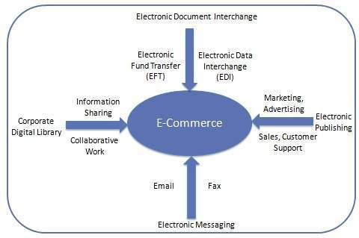

Types of Ecommerce Frameworks
You can choose among three primary types of ecommerce frameworks. All three will work a little bit differently, and all three have their own strengths and weaknesses. Those frameworks are:
- SaaS.
- Open source.
- Headless commerce.

1. SaaS Ecommerce Framework.
SaaS stands for “software as a service.” Users subscribe — as opposed to buying — to software that the vendor continues to host, maintain and improve. SaaS platforms, on average, come with more out-of-the-box functionality. And, while customization is limited, SaaS platforms today are becoming more and more flexible thanks to APIs and pre-built integrations.
Pros:
- The vendor can push out real-time feature upgrades as they continue to improve the software over time.
- Total cost of ownership is typically much less than with an open source or headless commerce frameworks.
- SaaS can help you get to market quickly.
- Security and maintenance are included in your costs, and you won’t have to worry about hosting.
Cons:
- Not as customizable as open source or headless commerce frameworks.

2. Open Source Ecommerce Framework.
Open source software is software that allows users to access and change the source code on their own software instance. It’s often — but not always — written in PHP, a popular general purpose scripting language. Open source ecommerce platforms offer a high level of customization, but it comes at a cost.
You’ll need developers to not just make the customization's you want, but also to maintain the code over time — the more customization, the higher the risk of unintended consequences — and ensure continued cybersecurity defenses to protect your business and your shoppers.
Pros:
- Almost limitless customization opportunities.
- Engaged communities of developers.
Cons:
- You’ll be responsible for installing software updates and security patches.
- The ability to customize also means that the software is more complex, and you’ll be more reliant on developers not just at implementation but over the lifecycle of your business.
- The TCO is typically high once you factor in all the related extraneous costs. (No software is ever truly “free.”)

3. Headless Ecommerce Framework.
Headless commerce decouples the back- and front-ends so retailers can choose their own front-end presentation layer to deliver a differentiated customer experience by leveraging a composable architecture approach. This also gives you the opportunity to take a multi-vendor approach, using one vendor for the back-end solution and something different on the front.
Decoupled approaches like headless are a potential advantage to enterprise businesses because they allow for greater freedom and control. You can also develop some elements of your system to operate independently from each other instead of having everything be fully joined together.
Pros:
- You’ll have the flexibility to use the front-end of your choice, from digital experience platforms to PWAs and more.
- You can use your back-end to power multiple front-ends for a multi-site experience.
- When your front- and back-ends are decoupled, each can undergo development work without risking impacts to each other.
Cons:
- The total cost of ownership can be high, because you’ll be paying for your back-end, front-end and development work.
- Architectures can be complex and require developer expertise.

Electronic Commerce
Electronic commerce or simply ecommerce is normally a process that involves facilitating the availability of products and services online. The users can search, choose, sell, buy from a wide range of options through Internet.
The major activities of ecommerce are as follows −
- Selling products and services online (through internet)
- Buying products and services online
- Paying and accepting payment online
- Transaction of businesses and other services online

Features of E-Commerce
Following are the important features of ecommerce −
- It efficiently increases the business capability.
- It substantially reduces the cost.
- It perceptively increases the delivery services.
- It unbreakable solution of quick business transactions and office automation.
- It potentially increases the intra-business functionality.
- It competently increases the business communication.

Types of E-Commerce
Following are the major types of e-commerce businesses −

Business-to-Business (B2B)
It is conducted between two business firms.

Business-to-Consumer (B2C)
It is conducted between the business firm and the consumer.

Consumer-to-Consumer (C2C)
Consumer-to-consumer business deals happen between two consumers; there are certain websites that facilitate a common platform to both the consumers - one who wants to buy and one who wants to sell.

Benefits of E-Commerce
Let us now discuss the benefits of e-commerce −
- It facilitates free market.
- It is available 24×7.
- Its presence is global (there is no constrain of political boundary as such).
- Set up cost is substantially low.
- It provides user-friendly technology.
- It offers multiple opportunity parallel and simultaneously.
- It provides frugal facilities to promote and market businesses.
- It has features to offer market research facility.
- It makes customer relations management easier.
- It facilitates the provision of 24×7 customer care services.
- It provides fund transfer facility domestically as well as internationally with simple steps.

MEDIA COVERAGE
Media coverage means any reporting, recording, broadcasting, narrowcasting, cablecasting or webcasting of court proceedings by the media using TV, radio, photographic, recording, or other electronic devices.

Twisted Pair Cable
Copper wires are the most common wires used for transmitting signals because of good performance at low costs. They are most commonly used in telephone lines. However, if two or more wires are lying together, they can interfere with each other’s signals. To reduce this electromagnetic interference, pair of copper wires are twisted together in helical shape like a DNA molecule. Such twisted copper wires are called twisted pair. To reduce interference between nearby twisted pairs, the twist rates are different for each pair.
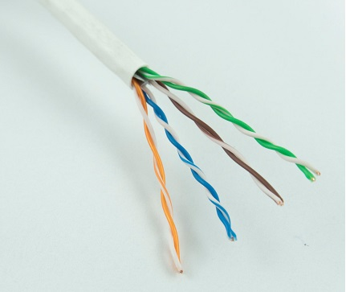
Up to 25 twisted pair are put together in a protective covering to form twisted pair cables that are the backbone of telephone systems and Ethernet networks.

Advantages of twisted pair cable
Twisted pair cable is the oldest and most popular cables all over the world. This is due to the many advantages that they offer −
- Trained personnel easily available due to shallow learning curve
- Can be used for both analog and digital transmissions
- Least expensive for short distances
- Entire network does not go down if a part of network is damaged

Disadvantages of twisted pair cable
With its many advantages, twisted pair cables offer some disadvantages too −
- Signal cannot travel long distances without repeaters
- High error rate for distances greater than 100m
- Very thin and hence breaks easily
- Not suitable for broadband connections

Shielding twisted pair cable
To counter the tendency of twisted pair cables to pick up noise signals, wires are shielded in the following three ways −
- Each twisted pair is shielded.
- Set of multiple twisted pairs in the cable is shielded.
- Each twisted pair and then all the pairs are shielded.
Such twisted pairs are called shielded twisted pair (STP) cables. The wires that are not shielded but simply bundled together in a protective sheath are called unshielded twisted pair (UTP) cables. These cables can have maximum length of 100 metres.
Shielding makes the cable bulky, so UTP are more popular than STP. UTP cables are used as the last mile network connection in homes and offices.

Coaxial Cable
Coaxial cables are copper cables with better shielding than twisted pair cables, so that transmitted signals may travel longer distances at higher speeds. A coaxial cable consists of these layers, starting from the innermost −
- Stiff copper wire as core
- Insulating material surrounding the core
- Closely woven braided mesh of conducting material surrounding the insulator
- Protective plastic sheath encasing the wire
Coaxial cables are widely used for cable TV connections and LANs.
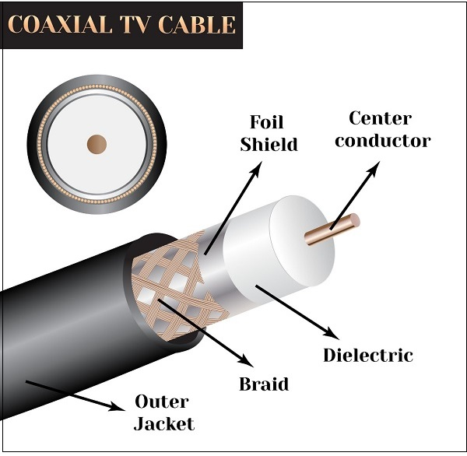

Advantages of Coaxial Cables
These are the advantages of coaxial cables −
- Excellent noise immunity
- Signals can travel longer distances at higher speeds, e.g. 1 to 2 Gbps for 1 Km cable
- Can be used for both analog and digital signals
- Inexpensive as compared to fibre optic cables
- Easy to install and maintain

Disadvantages of Coaxial Cables
These are some of the disadvantages of coaxial cables −
- Expensive as compared to twisted pair cables
- Not compatible with twisted pair cables

Optical Fibre
Thin glass or plastic threads used to transmit data using light waves are called optical fibre. Light Emitting Diodes (LEDs) or Laser Diodes (LDs) emit light waves at the source, which is read by a detector at the other end. Optical fibre cable has a bundle of such threads or fibres bundled together in a protective covering. Each fibre is made up of these three layers, starting with the innermost layer −
- Core made of high quality silica glass or plastic
- Cladding made of high quality silica glass or plastic, with a lower refractive index than the core
- Protective outer covering called buffer
Note that both core and cladding are made of similar material. However, as refractive index of the cladding is lower, any stray light wave trying to escape the core is reflected back due to total internal reflection.
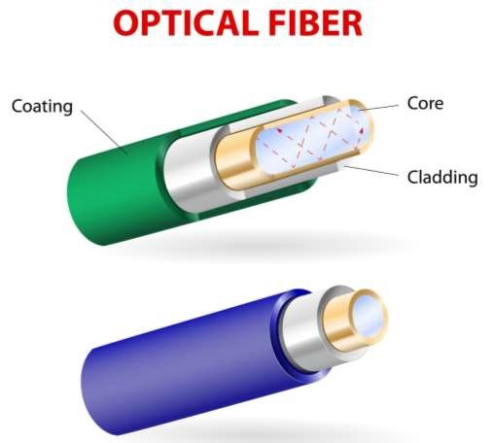
Optical fibre is rapidly replacing copper wires in telephone lines, internet communication and even cable TV connections because transmitted data can travel very long distances without weakening. Single node fibre optic cable can have maximum segment length of 2 kms and bandwidth of up to 100 Mbps. Multi-node fibre optic cable can have maximum segment length of 100 kms and bandwidth up to 2 Gbps.

Advantages of Optical Fibre
Optical fibre is fast replacing copper wires because of these advantages that it offers −
- High bandwidth
- Immune to electromagnetic interference
- Suitable for industrial and noisy areas
- Signals carrying data can travel long distances without weakening

Disadvantages of Optical Fibre
Despite long segment lengths and high bandwidth, using optical fibre may not be a viable option for every one due to these disadvantages −
- Optical fibre cables are expensive
- Sophisticated technology required for manufacturing, installing and maintaining optical fibre cables
- Light waves are unidirectional, so two frequencies are required for full duplex transmission

Infrared
Low frequency infrared waves are used for very short distance communication like TV remote, wireless speakers, automatic doors, hand held devices etc. Infrared signals can propagate within a room but cannot penetrate walls. However, due to such short range, it is considered to be one of the most secure transmission modes.
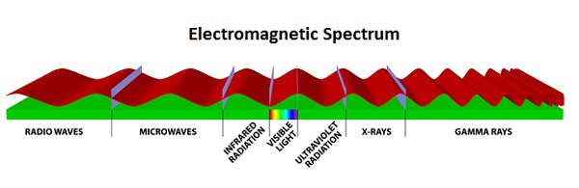

Radio Wave
Transmission of data using radio frequencies is called radio-wave transmission. We all are familiar with radio channels that broadcast entertainment programs. Radio stations transmit radio waves using transmitters, which are received by the receiver installed in our devices.
Both transmitters and receivers use antennas to radiate or capture radio signals. These radio frequencies can also be used for direct voice communication within the allocated range. This range is usually 10 miles.

Advantages of Radio Wave
These are some of the advantages of radio wave transmissions −
- Inexpensive mode of information exchange
- No land needs to be acquired for laying cables
- Installation and maintenance of devices is cheap

Disadvantages of Radio Wave
These are some of the disadvantages of radio wave transmissions −
- Insecure communication medium
- Prone to weather changes like rain, thunderstorms, etc.

Anatomy of E-Commerce applications
•Multimedia Content for E-Commerce Applications
•Multimedia Storage Servers & E-Commerce Applications
i. Client-Server Architecture in Electronic Commerce
ii. Internal Processes of Multimedia Servers
iii. Video Servers & E-Commerce
•Information Delivery/Transport & E-Commerce Applications
•Consumer Access Devices

Multimedia Content for E-Commerce Applications

•Multimedia content can be considered both fuel and traffic for electronic commerce applications.
•The technical definition of multimedia is the use of digital data in more than one format, such as the combination of text, audio, video, images, graphics, numerical data, holograms, and animations in a computer file/document. See in Fig.
•Multimedia is associated with Hardware components in different networks.
•The Accessing of multimedia content depends on the hardware capabilities of the customer.

Multimedia Storage Servers & E-Commerce Applications

•E-Commerce requires robust servers to store and distribute large amounts of digital content to consumers.

•These Multimedia storage servers are large information warehouses capable of handling various content, ranging from books, newspapers, advertisement catalogs, movies, games, & X-ray images.

•These servers, deriving their name because they serve information upon request, must handle large-scale distribution, guarantee security, & complete reliability

i. Client-Server Architecture in Electronic Commerce

•All e-commerce applications follow the client-server model
•Clients are devices plus software that request information from servers or interact known as message passing
•Mainframe computing, which meant for “dump?”
•The client server model, allows client to interact with server through request-reply sequence governed by a paradigm known as message passing.
•The server manages application tasks, storage & security & provides scalability-ability to add more clients and client devices (like Personal digital assistants to Pc’s. See in fig.

ii. Internal Processes of Multimedia Servers

•The internal processes involved in the storage, retrieval & management of multimedia data objects are integral to e-commerce applications.

•A multimedia server is a hardware & software combination that converts raw data into usable information & then dishes out.

•It captures, processes, manages, & delivers text, images, audio & video.

•It must do to handle thousands of simultaneous users.
•Include high-end symmetric multiprocessors, clustered architecture, and massive parallel systems.

iii. Video Servers & E-Commerce

The electronic commerce applications related to digital video will include
1. Telecommunicating and video conferencing
2. Geographical information systems that require storage &
Navigation over maps
3. Corporate multimedia servers
4. Postproduction studios
5. Shopping kiosks.
•Consumer applications will include video-on-demand.
•The figure which is of video–on demand consist video servers, is an link between the content providers (media) & transport providers (cable operators)

Information Delivery/Transport & E-Commerce Applications

•Transport providers are principally telecommunications, cable, & wireless industries.

1 Information Transport Providers Information Delivery Methods

2 Telecommunication companies long-distance telephone lines;
local telephone lines

3 Cable television companies Cable TV coaxial, fiber optic &
Satellite lines

4 Computer-based on-line servers Internet; commercial on-line
Service providers

5 Wireless communications Cellular & radio networks;
Paging systems

Consumer Access Devices

Information Consumers Access Devices

1Computers with audio & video Personal/desktop computing

2 Capabilities Mobile computing

3. Telephonic devices Videophone

4 Consumer electronics Television + set-top box Game
systems
5 Personal digital assistants (PDAs) Pen-based computing, voice-
Driven computing

common applications of Ecommerce:
- Retail and Wholesale
Ecommerce has numerous applications in this sector. E-retailing is basically a B2C, and in some cases, a B2B sale of goods and services through online stores designed using virtual shopping carts and electronic catalogs. A subset of retail ecommerce is m-commerce, or mobile commerce, wherein a consumer purchases goods and services using their mobile device through the mobile optimized site of the retailer. These retailers use the E-payment method: they accept payment through credit or debit cards, online wallets or internet banking, without printing paper invoices or receipts.
- Online Marketing
This refers to the gathering of data about consumer behaviors, preferences, needs, buying patterns and so on. It helps marketing activities like fixing price, negotiating, enhancing product features, and building strong customer relationships as this data can be leveraged to provide customers a tailored and enhanced purchase experience.
- Finance
Banks and other financial institutions are using e-commerce to a significant extent. Customers can check account balances, transfer money to other accounts held by them or others, pay bills through internet banking, pay insurance premiums, and so on. Individuals can also carry out trading in stocks online, and get information about stocks to trade in from websites that display news, charts, performance reports and analyst ratings of companies.
- Manufacturing
Supply chain operations also use ecommerce; usually, a few companies form a group and create an electronic exchange and facilitate purchase and sale of goods, exchange of market information, back office information like inventory control, and so on. This enables the smooth flow of raw materials and finished products among the member companies and also with other businesses.
- Online Booking
This is something almost every one of us has done at some time – book hotels, holidays, airline tickets, travel insurance, etc. These bookings and reservations are made possible through an internet booking engine or IBE. It is used the maximum by aviation, tour operations and hotel industry.
- Online Publishing
This refers to the digital publication of books, magazines, catalogues, and developing digital libraries.
- Digital Advertising
Online advertising uses the internet to deliver promotional material to consumers; it involves a publisher, and an advertiser. The advertiser provides the ads, and the publisher integrates ads into online content. Often there are creative agencies which create the ad and even help in the placement. Different types of ads include banner ads, social media ads, search engine marketing, retargeting, pop-up ads, and so on.
- Auctions
Online auctions bring together numerous people from various geographical locations and enable trading of items at negotiated prices, implemented with e-commerce technologies. It enables more people to participate in auctions. Another example of auction is bidding for seats on an airline website – window seats, and those at the front with more leg room generally get sold at a premium, depending on how much a flyer is willing to pay.
E-Commerce is all around us today, and as an entrepreneur, you should also get into this realm if you want to expand your markets, get more customers and increase your profitability.

